**1. Write a PL/SQL stored Procedure for following requirements and call the procedure in**

**appropriate PL/SQL block.**

**1. Borrower(Rollin, Name, DateofIssue, NameofBook, Status)**

**2. Fine(Roll_no,Date,Amt)**

**Accept roll_no &name of book from user.**

**Check the number of days (from date of issue), if days are between 15 to 30 then fine**

**amount will be Rs 5per day.**

**If no. of days>30, per day fine will be Rs 50 per day & for days less than 30, Rs. 5 per**

**day.**

**After submitting the book, status will change from I to R.**

**If condition of fine is true, then details will be stored into fine table.**

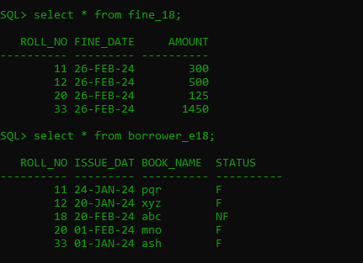

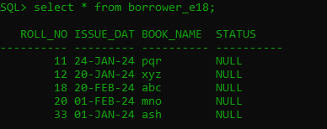

**Procedure code:-**

CREATE OR REPLACE PROCEDURE student_18(mroll in number,

mbook in varchar)

is

datediff number(10);

mdate date;

mfine number;

invalid_input EXCEPTION;

begin

select issue_date into mdate from borrower_e18 where roll_no=mroll and book_name=mbook;

datediff:=to_date(sysdate)-to_date(mdate);

-- Check for overdue

IF datediff < 0 THEN

RAISE invalid_input; -- Negative date difference indicates invalid input

end if;

IF datediff < 15 then

dbms_output.put_line('No Fine');

update borrower_e18 set status='NF' where roll_no=mroll and book_name=mbook;

ELSIF datediff > 15 and datediff < 30 then

mfine:=(datediff*5);

dbms_output.put_line('Fine is: '||mfine);

update borrower_e18 set status='F' where roll_no=mroll and book_name=mbook;

insert into fine_18 values(mroll,sysdate,mfine);

ELSIF datediff > 30 then

mfine:=((datediff-30)*50+(30*5));

dbms_output.put_line('Fine is: '||mfine);

update borrower_e18 set status='F' where roll_no=mroll and book_name=mbook;

insert into fine_18 values(mroll,sysdate,mfine);

End if;

Exception

WHEN invalid_input THEN

dbms_output.put_line('Invalid input: Book return date is after current date.');

End student_18 ;

/

**Procedure Calling code:-**

DECLARE

mroll borrower_e18.roll_no%TYPE;

mbook borrower_e18.book_name%TYPE;

BEGIN

mroll := &roll_no;

mbook := '&book_name';

student_18(mroll, mbook);

EXCEPTION

WHEN OTHERS THEN

DBMS_OUTPUT.PUT_LINE('An error occurred: ' || SQLERRM);

END;

/

**2. Write a stored function in PL/SQL for given requirement and use the same in PL/SQL block. Account no. and branch name will be accepted from user. The same will be searched in table acct_details. If status of account is active then display appropriate message and also store the account details in active_acc_details table, otherwise display message on screen “account is inactive”**

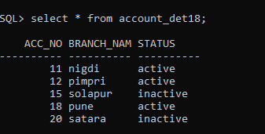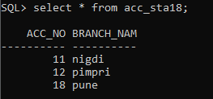

FUNCTION CODE:-

create or replace function acc_18(macc_no in number,mbranch_name in varchar)

return number

is

mstatus varchar(15);

begin

select status into mstatus from account_det18 where acc_no=macc_no and branch_name = mbranch_name;

if mstatus='active' then

insert into acc_sta18 values(macc_no,mbranch_name);

return 1;

else

return 0;

end if;

end;

/

FUNCTION CALL:-

declare

macc_no number;

mbranch_name varchar(15);

ch number;

begin

macc_no := &acc_no;

mbranch_name := '&branch_name';

ch := acc_18(macc_no,mbranch_name);

if ch=1 then

dbms_output.put_line('THE ACCOUNT IS ACTIVE');

else

dbms_output.put_line('THE ACCOUNT IS INACTIVE');

end if;

end;

/

**Que3. Write a Stored Procedure namely proc_Grade for the categorization of student. If marks scored by students in examination is <=1500 and marks>=990 then student will be placed in distinction category if marks scored are between 989 and900 category is first class, if marks 899 and 825 category is Higher Second Class Write a PL/SQL block for using procedure created with above requirement. Stud_Marks(name, total_marks) Result(Roll,Name, Class).**

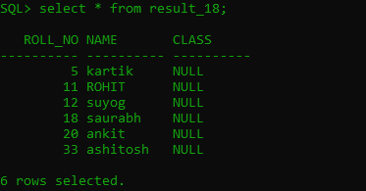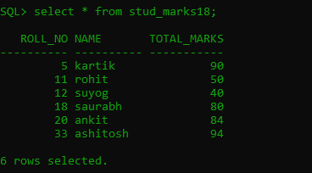

**AFTER CODE RUN:-**

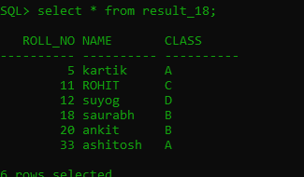

**Procedure code:-**

Create or Replace Procedure proc_grade(mmarks in

number, mroll in number) is

Begin

if mmarks>=90 and mmarks <=100 then

update result_18 set class= 'A' where roll_no=mroll;

elsif mmarks>=60 and mmarks<=89 then

update result_18 set class='B' where roll_no=mroll;

elsif mmarks>=50 and mmarks<60 then

update result_18 set class='C' where roll_no=mroll;

else

update result_18 set class='D' where roll_no=mroll;

end if;

End;

**/**

**Procedure Call Code:-**

Declare

mmarks number(4);

mroll number(4);

Begin

mroll:=&roll;

select roll_no,total_marks into mroll,mmarks from stud_marks18

where roll_no=mroll ;

proc_grade(mmarks, mroll );

End;